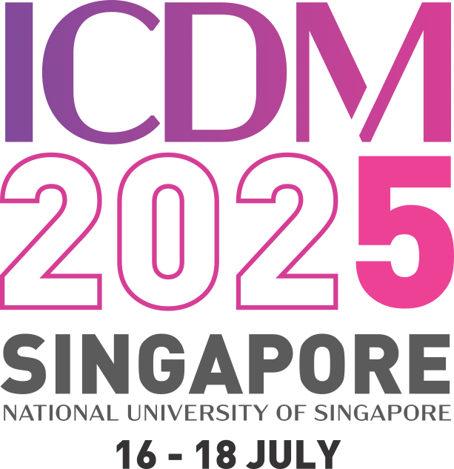
The Fifth International Conference on Damage Mechanics (ICDM5)
Date: 16th - 18th July 2025
Venue: National University of Singapore

Abstract Title | A review of continuum damage and plasticity in concrete
List of authors & their affiliations with the presenter’s name underlined. Provide email contact for the presenter. | Taehyo Park¹, Bilal Ahmed¹, George Z. Voyiadjis²  ¹Hanyang University  ² Louisiana State University  Email: cegzv1@lsu.edu
Abstract
In the past few decades, extensive research on concrete modeling to predict behavior, crack propagation, microcrack coalescence by utilizing different approaches (fracture mechanics, continuum damage mechanics) were investigated theoretically and numerically. The presented work aims to review the theoretical work of continuum concrete damage and plasticity modeling.

